GCSE
FRENCH
Translation Higher Tier
Version 0.2

Total number of marks: 63

Translation into English:

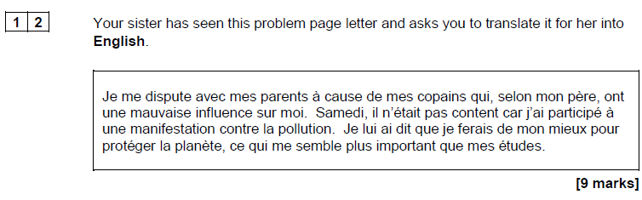

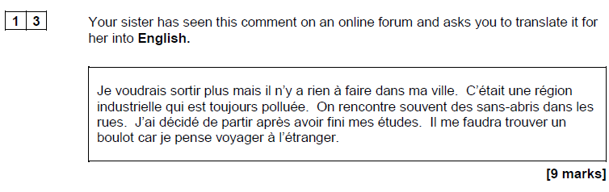

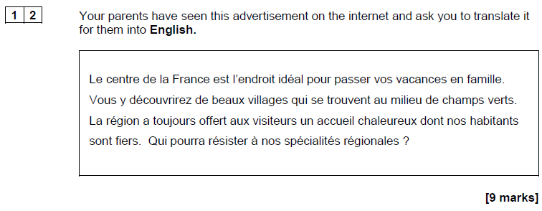

Translation into French:

