GCSE
FRENCH
Translation Foundation Tier
Version 0.1

Total number of marks: 57

Translation into English:

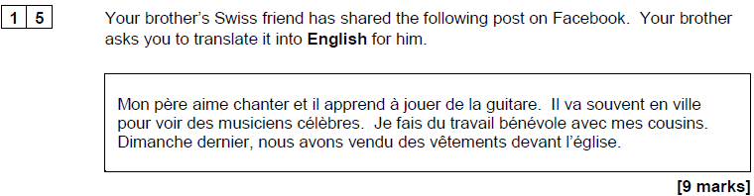

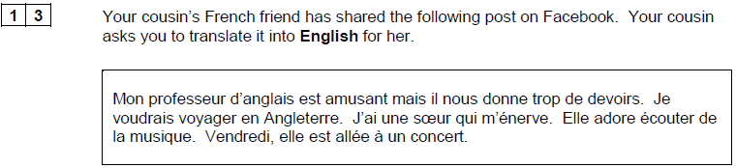
[9 marks]

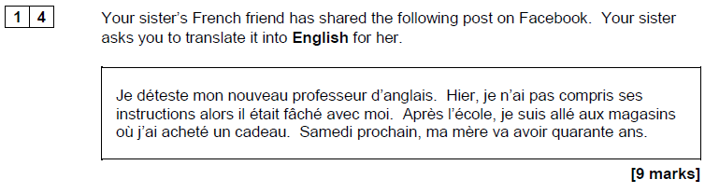

Translation into French:

