GCSE
FRENCH
Reading Higher Tier Theme 2 Local, national, international and global areas of interest

Total number of marks: 16

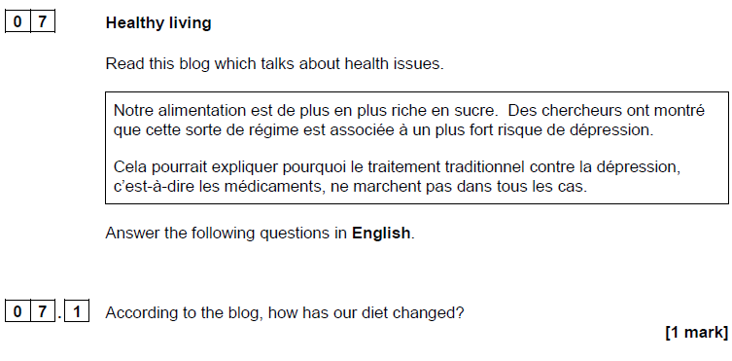

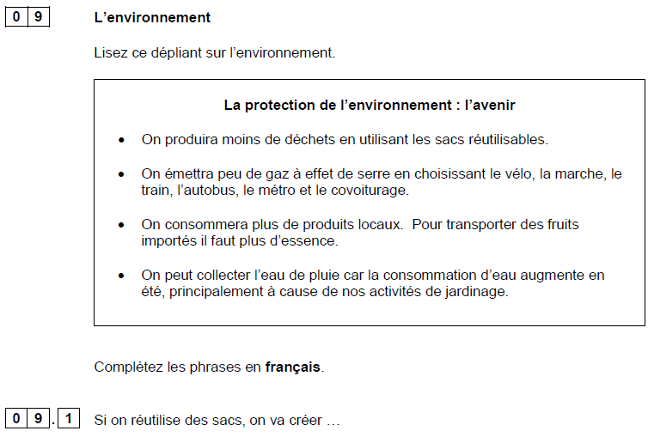
[1 mark]

[1 mark]

[1 mark]

[1 mark]

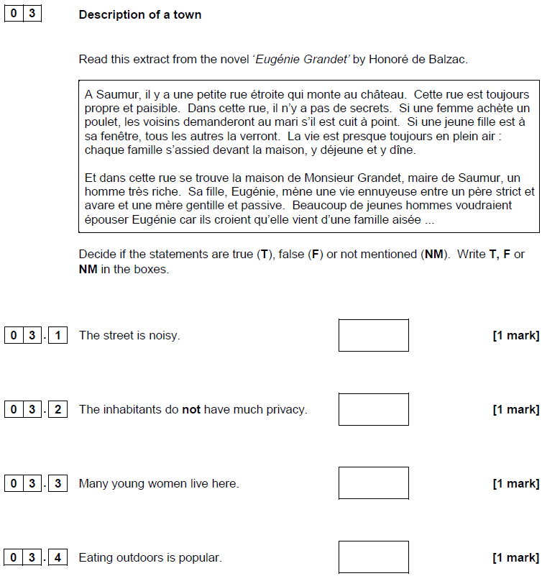

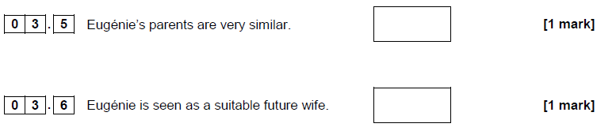

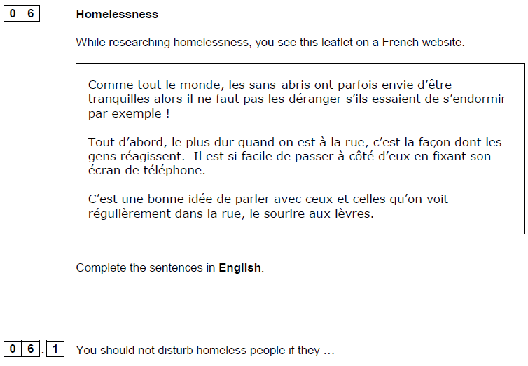
[1 mark]

[1 mark]

[1 mark]

