GCSE
CHINESE (MANDARIN)
Translation Higher Tier

Total number of marks: 63

Translation into English:

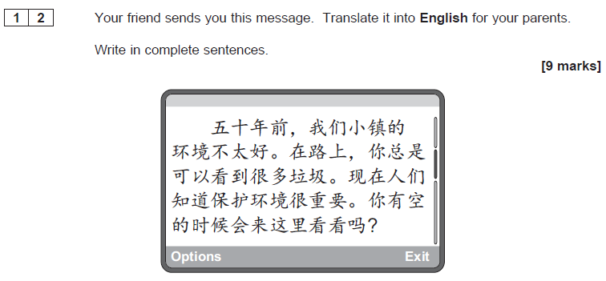

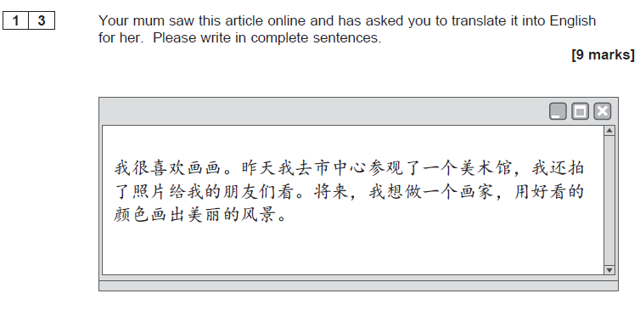
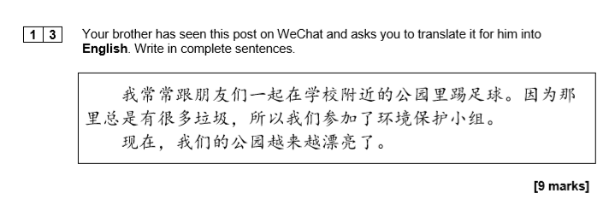

Translation into Chinese (Mandarin):

