GCSE
CHINESE (MANDARIN)
Translation Foundation Tier

Total number of marks: 57

Translation into English:

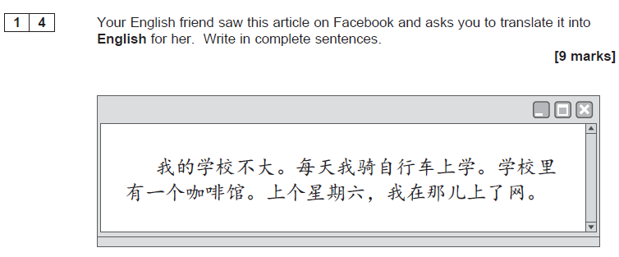

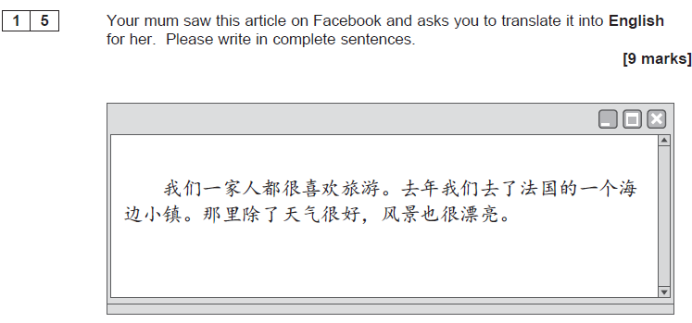

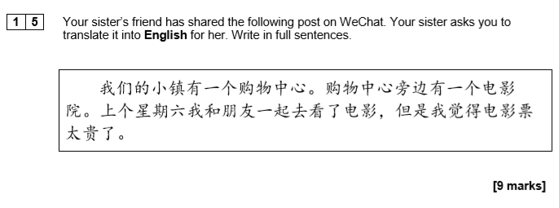

Translation into Chinese:

