GCSE
CHINESE (MANDARIN)
Reading Higher Tier Theme 3 - Current and future study and employment

Total number of marks: 14

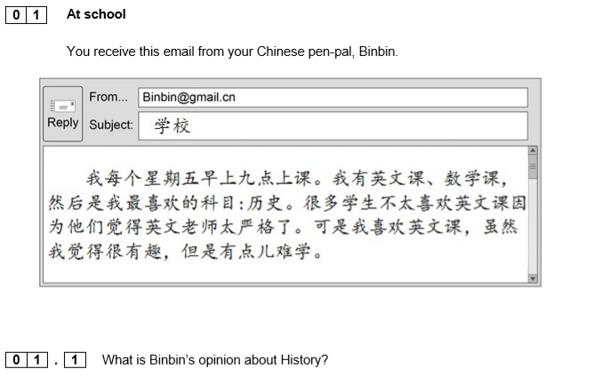[1 mark]

[1 mark]
[1 mark]
[1 mark]

