GCSE
CHINESE (MANDARIN)
Reading Higher Tier Theme 2 - Local, national, international and global areas of interest

Total number of marks: 14

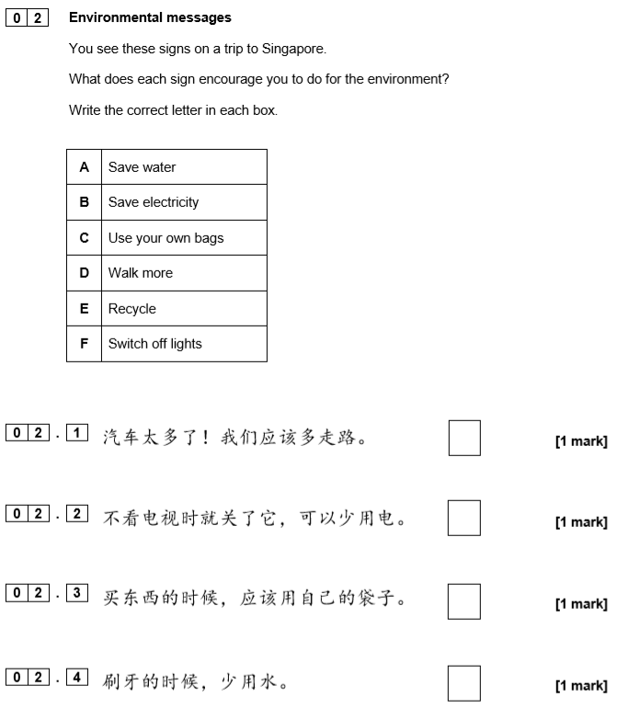

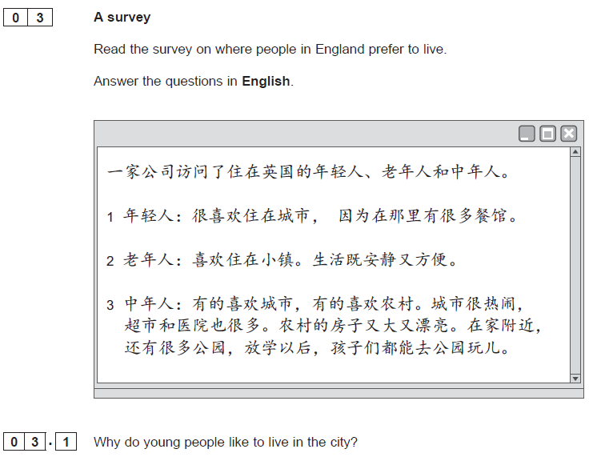[1 mark]

[1 mark]

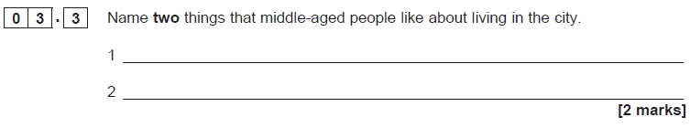
[1 mark]

