GCSE
CHINESE (MANDARIN)
Reading Higher Tier Theme 1 - Identity and culture

Total number of marks: 14

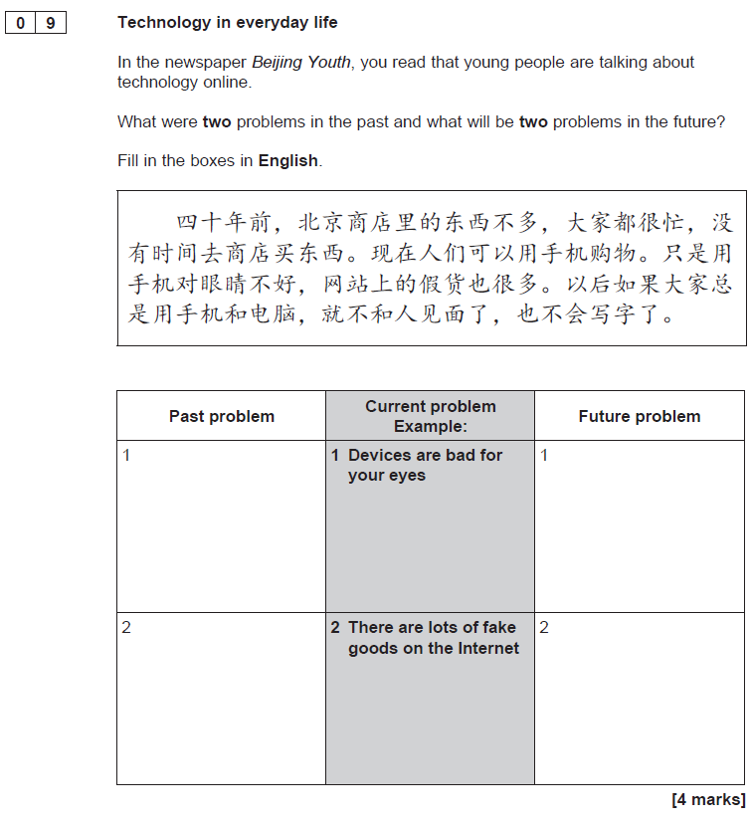

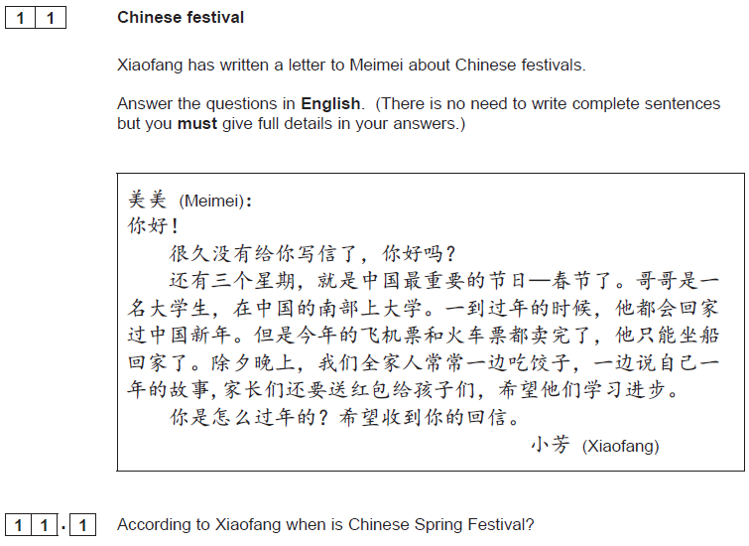[1 mark]

[1 mark]

[1 mark]

