GCSE
CHINESE (MANDARIN)
Reading Foundation Tier Theme 1 Identity and culture

Total number of marks: 15

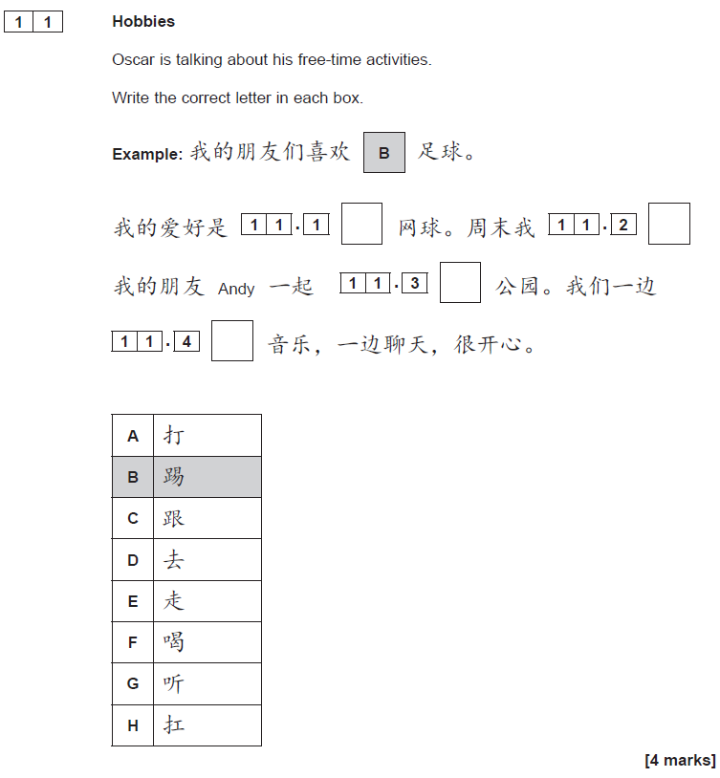

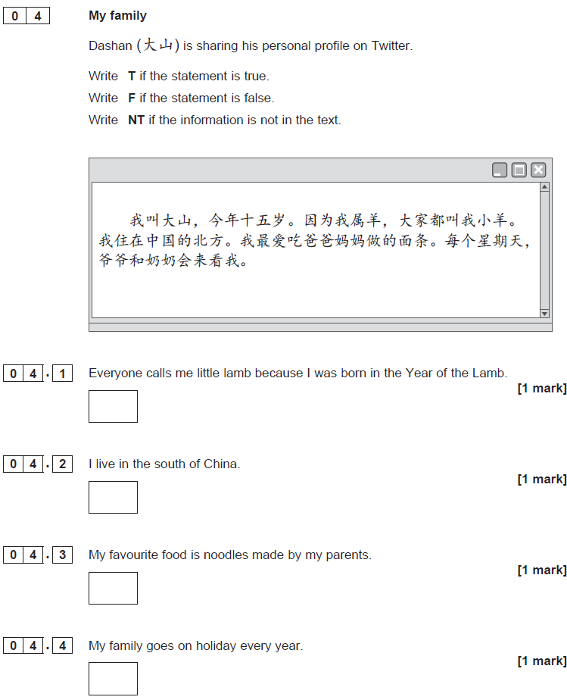

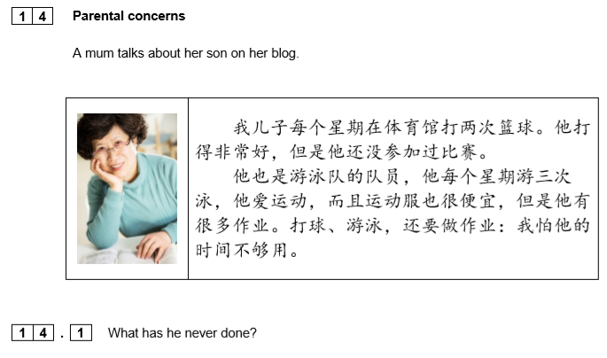[1 mark]

[1 mark]

[1 mark]

