|  |
| --- |
| GCSE |
| CHINESE (MANDARIN) |
| Listening Higher Tier Theme 2 Local, national, international and global areas of interest |

Total number of marks: 14

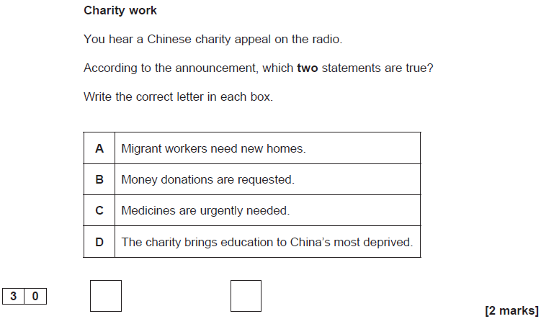

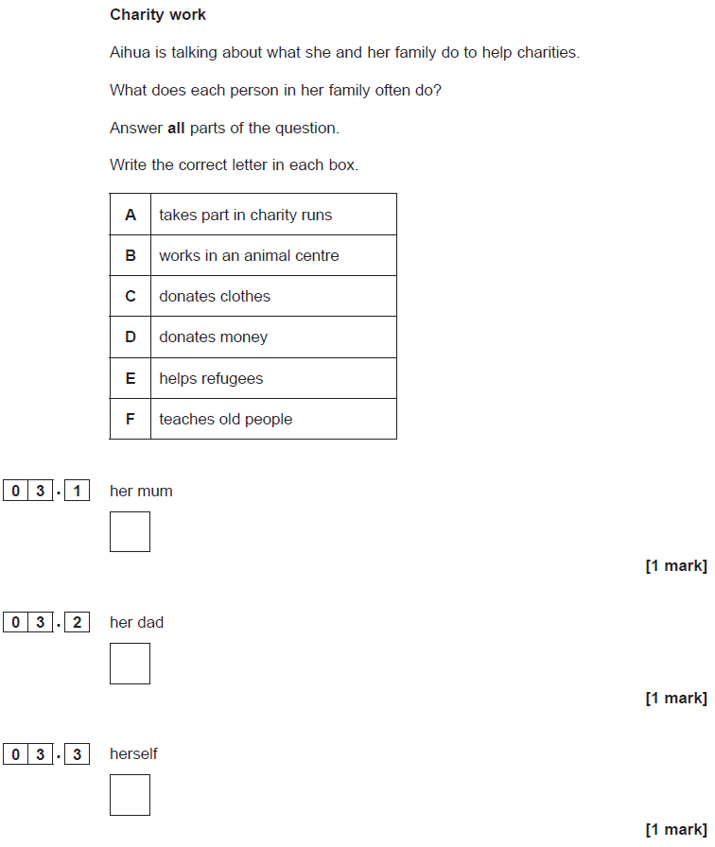

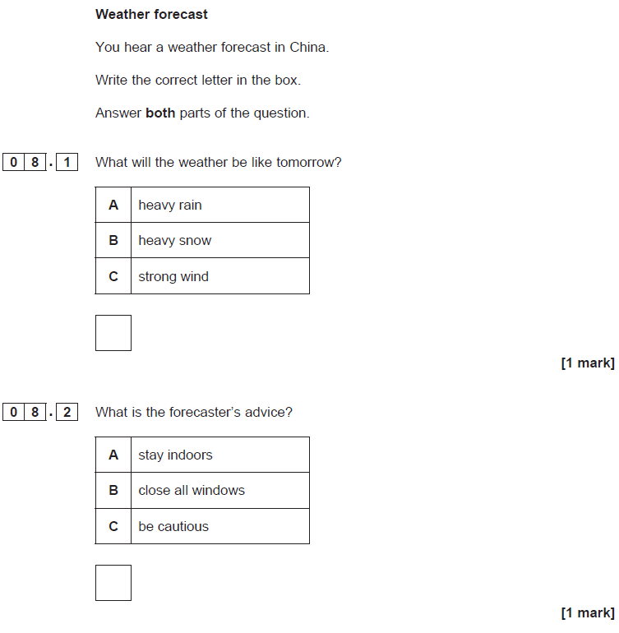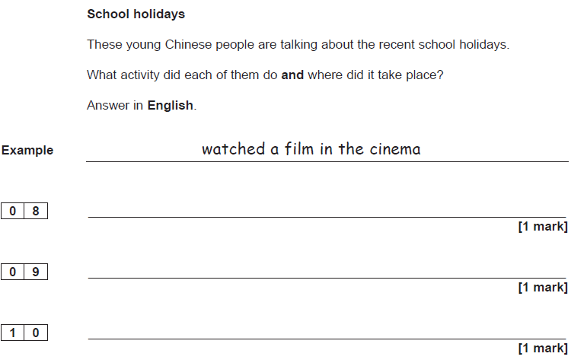

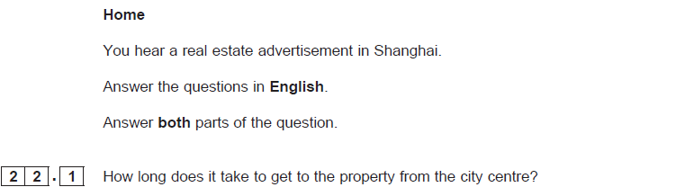**[1 mark][1 mark]**

