|  |
| --- |
| GCSE |
| CHINESE (MANDARIN) |
| Listening Higher Tier Theme 1 Identity and culture |
|  |

Total number of marks: 15

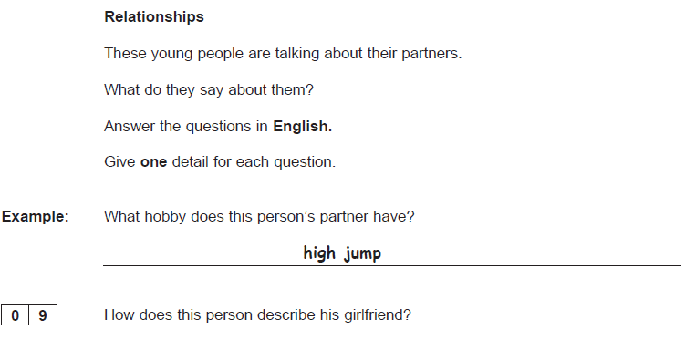**[1 mark]**

**[1 mark]**

**[1 mark]**



