|  |
| --- |
| GCSE |
| CHINESE (MANDARIN) |
| Listening Foundation Tier Theme 2 Local, national, international and global areas of interest |
|  |

Total number of marks: 14

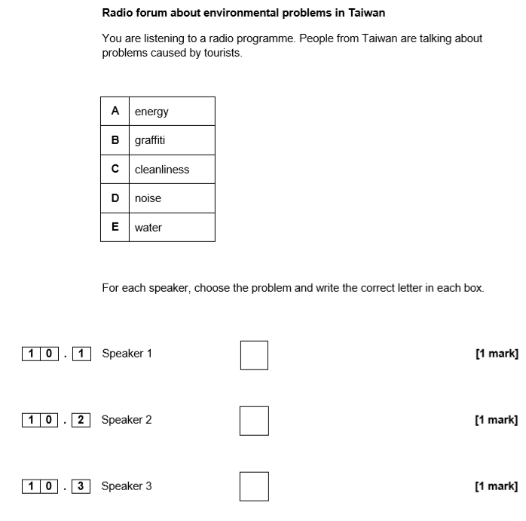

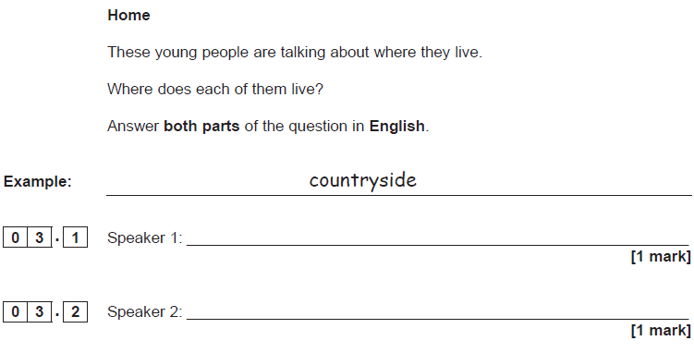

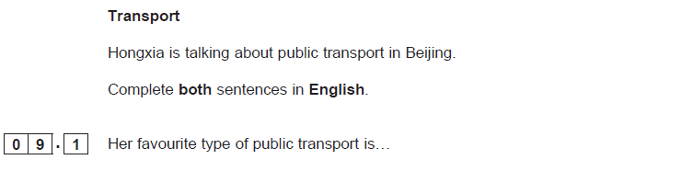**[1 mark]**

**[1 mark]**

