GCSE
CHINESE (MANDARIN)
Listening Foundation Tier Theme 1 Identity and culture

Total number of marks: 14

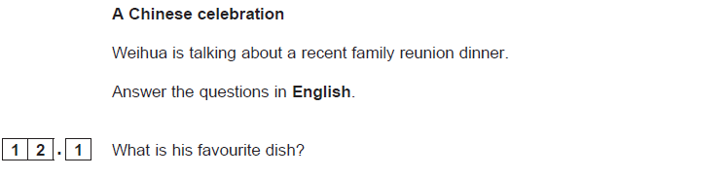[1 mark]
[1 mark]
[1 mark]

